**Word Search Game**

[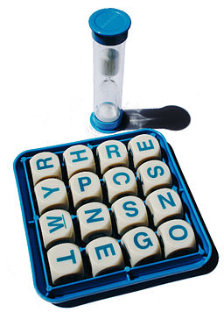](https://commons.wikimedia.org/wiki/File:Boggle.jpg)

**Problem Overview**

In this assignment, you will implement a version of a word search game much like [Boggle](https://en.wikipedia.org/wiki/Boggle) and other similar word games. The approach you take to finding words on the board will be a direct application of [depth-first search](https://en.wikipedia.org/wiki/Depth-first_search) with [backtracking](https://en.wikipedia.org/wiki/Backtracking).

The version of the game that you will implement is played on a square board according to the following rules.

1. Each position on the board contains one or more uppercase letters.
2. Words are formed by joining the contents of adjacent positions on the board.
3. Positions may be joined horizontally, vertically, or diagonally, and the board does not wrap around.
4. No position on the board may be used more than once within any one word.
5. A specified minimum word length (number of letters) is required for all valid words.
6. A specified lexicon is used to define the set of all valid words.

Below, from left to right, is a sample 4x4 board with single letters in each position, a sequence of positions forming the word PEACE, and the list of all words with a minimum length of 5 found on the board using the words in the standard Unix /usr/share/dict/words file as the lexicon.

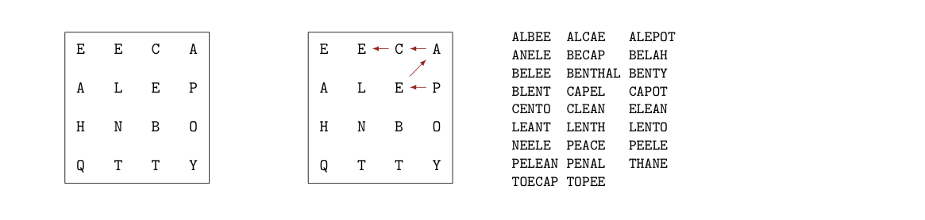

A string is said to be **on the board** if it can be constructed according to rules 1 through 4. A string is said to be a **valid word** if it is contained in the specified lexicon (rule 6). A **scorable word** is a valid word of at least the specified minimum length (rule 5) that is on the board.

HNTQ is on the board, but is not a valid word. PLACE, POPE, and PALE are valid words, but are not on the board. PEACE is a scorable word for any minimum length between 1 and 5. BOY is a valid word and it is on the board, but it would not be a scorable word if the specified minimum length is 4 or greater.

The score for a scorable word is calculated as follows: one point for the minimum number of characters, and one point for each character beyond the minimum number. Thus, each scorable word of length K > M is worth 1 + (K - M) points, where M is the specified minimum length. For example, the scorable words of length five or more on the board above would earn a score of 31. (22 words of length 5, 3 words of length 6, and 1 word of length 7 give 22 + 6 + 3 = 31 points.)

**Implementation Details**

You must implement your solution to the assignment in terms of two provided files: WordSearchGame.java and WordSearchGameFactory.java, **plus** one class that you create from scratch all on your own. The interface WordSearchGame describes all the behavior that is necessary to play the game. So, we can think of this interface as the specification for a *game engine*. You must develop your own game engine that meets this specification. That is, you must write a class that implements the WordSearchGame interface. You can name this class anything you want and you can add as many additional methods as you like.

The WordSearchGameFactory is a class with a single [*factory method*](https://en.wikipedia.org/wiki/Factory_method_pattern) for creating game engines. You must modify the createGame method to return an instance of your class that implements the WordSearchGame interface. Factory classes like this are convenient ways of completely separating an implementation (your class) from a specification (the provided interface). For example, the test suite used for grading has been written completely in terms of the interface and without any knowledge of the specific classes used in your implementation.

A brief example client along with the corresponding output are given below. Although the class that implements the WordSearchGame interface must be in the same directory, the ExampleGameClient code is independent of its name or any other details of the class.

public class ExampleGameClient {

public static void main(String[] args) {

WordSearchGame game = WordSearchGameFactory.createGame();

game.loadLexicon("wordfiles/words.txt");

game.setBoard(new String[]{"E", "E", "C", "A", "A", "L", "E", "P", "H",

"N", "B", "O", "Q", "T", "T", "Y"});

System.out.print("LENT is on the board at the following positions: ");

System.out.println(game.isOnBoard("LENT"));

System.out.print("POPE is not on the board: ");

System.out.println(game.isOnBoard("POPE"));

System.out.println("All words of length 6 or more: ");

System.out.println(game.getAllScorableWords(6));

}

}

Corresponding output:

LENT is on the board at the following positions: [5, 6, 9, 14]

POPE is not on the board: []

All words of length 6 or more:

[ALEPOT, BENTHAL, PELEAN, TOECAP]

**Methods related to the lexicon**

The three methods in the WordSearchGame interface that relate to loading and searching the lexicon are loadLexicon, isValidWord, and isValidPrefix. While loadLexicon is called only once per game, isValidWord and isValidPrefix will be called heavily throughout game play. These two methods **must be efficient** if the game is to run with reasonable response times when using large lexicons. The choice of collection or data structure to store the lexicon will determine just how efficient these methods can be.

You have two basic choices to represent the lexicon: use a prebuilt collection from the JCF or implement your own custom data structure or collection. If you choose the former option, [TreeSet](https://docs.oracle.com/en/java/javase/14/docs/api/java.base/java/util/TreeSet.html) will offer very good performance and provide very convenient methods. If you choose the latter option, a [*trie*](https://en.wikipedia.org/wiki/Trie) will provide even better (time) performance and will be a fun challenge to implement. The choice is completely up to you. A good (and optional) idea would be to develop your solution with a TreeSet to store the lexicon and then, if you have plenty of time at the end, make an attempt at building your own trie (or similar custom data structure).

The loadLexicon method reads a list of words from a text file and stores each unique word in the data structure or collection that you select to represent the lexicon. You will notice that many of the words in the provided lexicon files are in lowercase while the game board is in uppercase. Be sure that the lexicon is loaded and all string comparisons are made in a case-insensitive manner. You will also notice that the provided lexicon files have different content and formats. Using a simple scanner, however, it is possible to use the same code to read in all the provided lexicon files.

Note that the lexicon must be loaded before calling many of the other WordSearchGame methods. If any method that is dependent on a lexicon is called before loadLexicon, your code must throw an IllegalStateException. See the source code documentation for details.

The isValidWord method searches the data structure that holds the lexicon for a specified string and indicates whether or not that string is present. If the string is present then it is a valid word. If the string is not present then it is not a valid word.

The isValidPrefix method searches the data structure that holds the lexicon to determine if any word in the lexicon begins with the specified string. For the purposes of this method, a string should be considered a prefix of itself. For example, “cat” is a prefix of “cat” as it is of “catalog”.

**Methods related to the board**

The setBoard method accepts an array of length N^2 that specifies the content of each position on the NxN board. The elements of the array are the Strings on the board listed in [row-major order](https://en.wikipedia.org/wiki/Row-_and_column-major_order). Thus, the elements in the array from index 0 to N^2 - 1 correspond to the positions on the board from left to right, top to bottom. The element at index 0 stores the contents of the board position (0, 0) - the upper left corner - and the element at index N^2 - 1 stores the contents of the board position (N-1, N-1) - the bottom right corner. In general, the String at index row * N + col is the content of board position (row, col).

For example, the array a = ["E", "E", "C", "A", "A", "L", "E", "P", "H", "N", "B", "O", "Q", "T", "T", "Y"] would correspond to the board show below on the left. The same board is shown below on the right but with each element annotated with its row-major position. Note that the letter N is at board position (2, 1), which corresponds to row-major position 2 * 4 + 1 = 9.



The primary responsibility of the setBoard method is to populate the data structure that you choose to represent the board with the contents of the provided array of Strings. Once again, the choice of data structure to represent the board should be made in support of the algorithms that will depend on it (see game play methods below). Two obvious data structure choices include (a) just keeping the one-dimensional array of strings as the board representation or (b) creating a two-dimensional array of strings to directly represent the two-dimensional board being modeled. Other choices are possible, and the one you pick is at your discretion.

The implementing class of the WordSearchGame interface must have a default board. Specifically, the above board should be set as the default so that it is available for game play even if the setBoard method has not been called.

The getBoard method returns a string representation of the current board suitable for printing to standard out (i.e., as an argument to System.out.println). There is no particular format required. Choose the format that is most helpful to you. This method will not be tested or graded.

**Methods related to game play**

The methods that implement game play options are getAllScorableWords, isOnBoard, and getScoreForWords. The getAllScorableWords method returns a [SortedSet](https://docs.oracle.com/en/java/javase/14/docs/api/java.base/java/util/SortedSet.html) of strings containing all scorable words on the board that are of a specified minimum length and can be constructed according to the game rules. If no words can be found, this method returns an empty SortedSet.

The isOnBoard method takes a string parameter and determines whether or not that string is **on the board** as defined above. If the string is on the board, this method returns a [List](https://docs.oracle.com/en/java/javase/14/docs/api/java.base/java/util/List.html) of [Integers](https://docs.oracle.com/en/java/javase/14/docs/api/java.base/java/lang/Integer.html) representing the row-major positions of each *substring*. (Remember: the board positions are filled with strings, not necessarily just single characters). For example, isOnBoard("PEACE") would return the list [7, 6, 3, 2, 1]. If the string is not on the board, this method returns an empty list. For example, isOnBoard("PALE") would return an empty list.



Both getAllScorableWords and isOnBoard can be implemented using slightly different versions of depth-first search. The specific depth-first algorithms that you implement must be efficient enough for use on large game boards with large lexicons.

The getScoreForWords method returns the cumulative score of all the *scorable* words in the given SortedSet.

**Provided word list files**

You have been provided with several word list files for creating lexicons.

* [CSW12.txt](https://hendrtd.github.io/comp-2210/modules/m5/assign/description/data/CSW12.txt): 270,163 unique words, used in international Scrabble tournaments
* [OWL.txt](https://hendrtd.github.io/comp-2210/modules/m5/assign/description/data/OWL.txt): 167,964 unique words, used in North American Scrabble tournaments
* [words.txt](https://hendrtd.github.io/comp-2210/modules/m5/assign/description/data/words.txt): 234,371 unique words, provided with Unix distributions
* [words_medium.txt](https://hendrtd.github.io/comp-2210/modules/m5/assign/description/data/words_medium.txt): 172,823 unique words, subset of the Unix list
* [words_small.txt](https://hendrtd.github.io/comp-2210/modules/m5/assign/description/data/words_small.txt): 19,912 unique words, small subset of the Unix list

Your solution should run efficiently with each of these files used for the lexicon.

**Acknowledgements**

Word search games of various sorts are popular CS 2 assignments because they bring together several important topics all in one place. This version of the word search problem owes thanks to (at least): Julie Zelenski, Owen Astrachan, and Mike Smith.